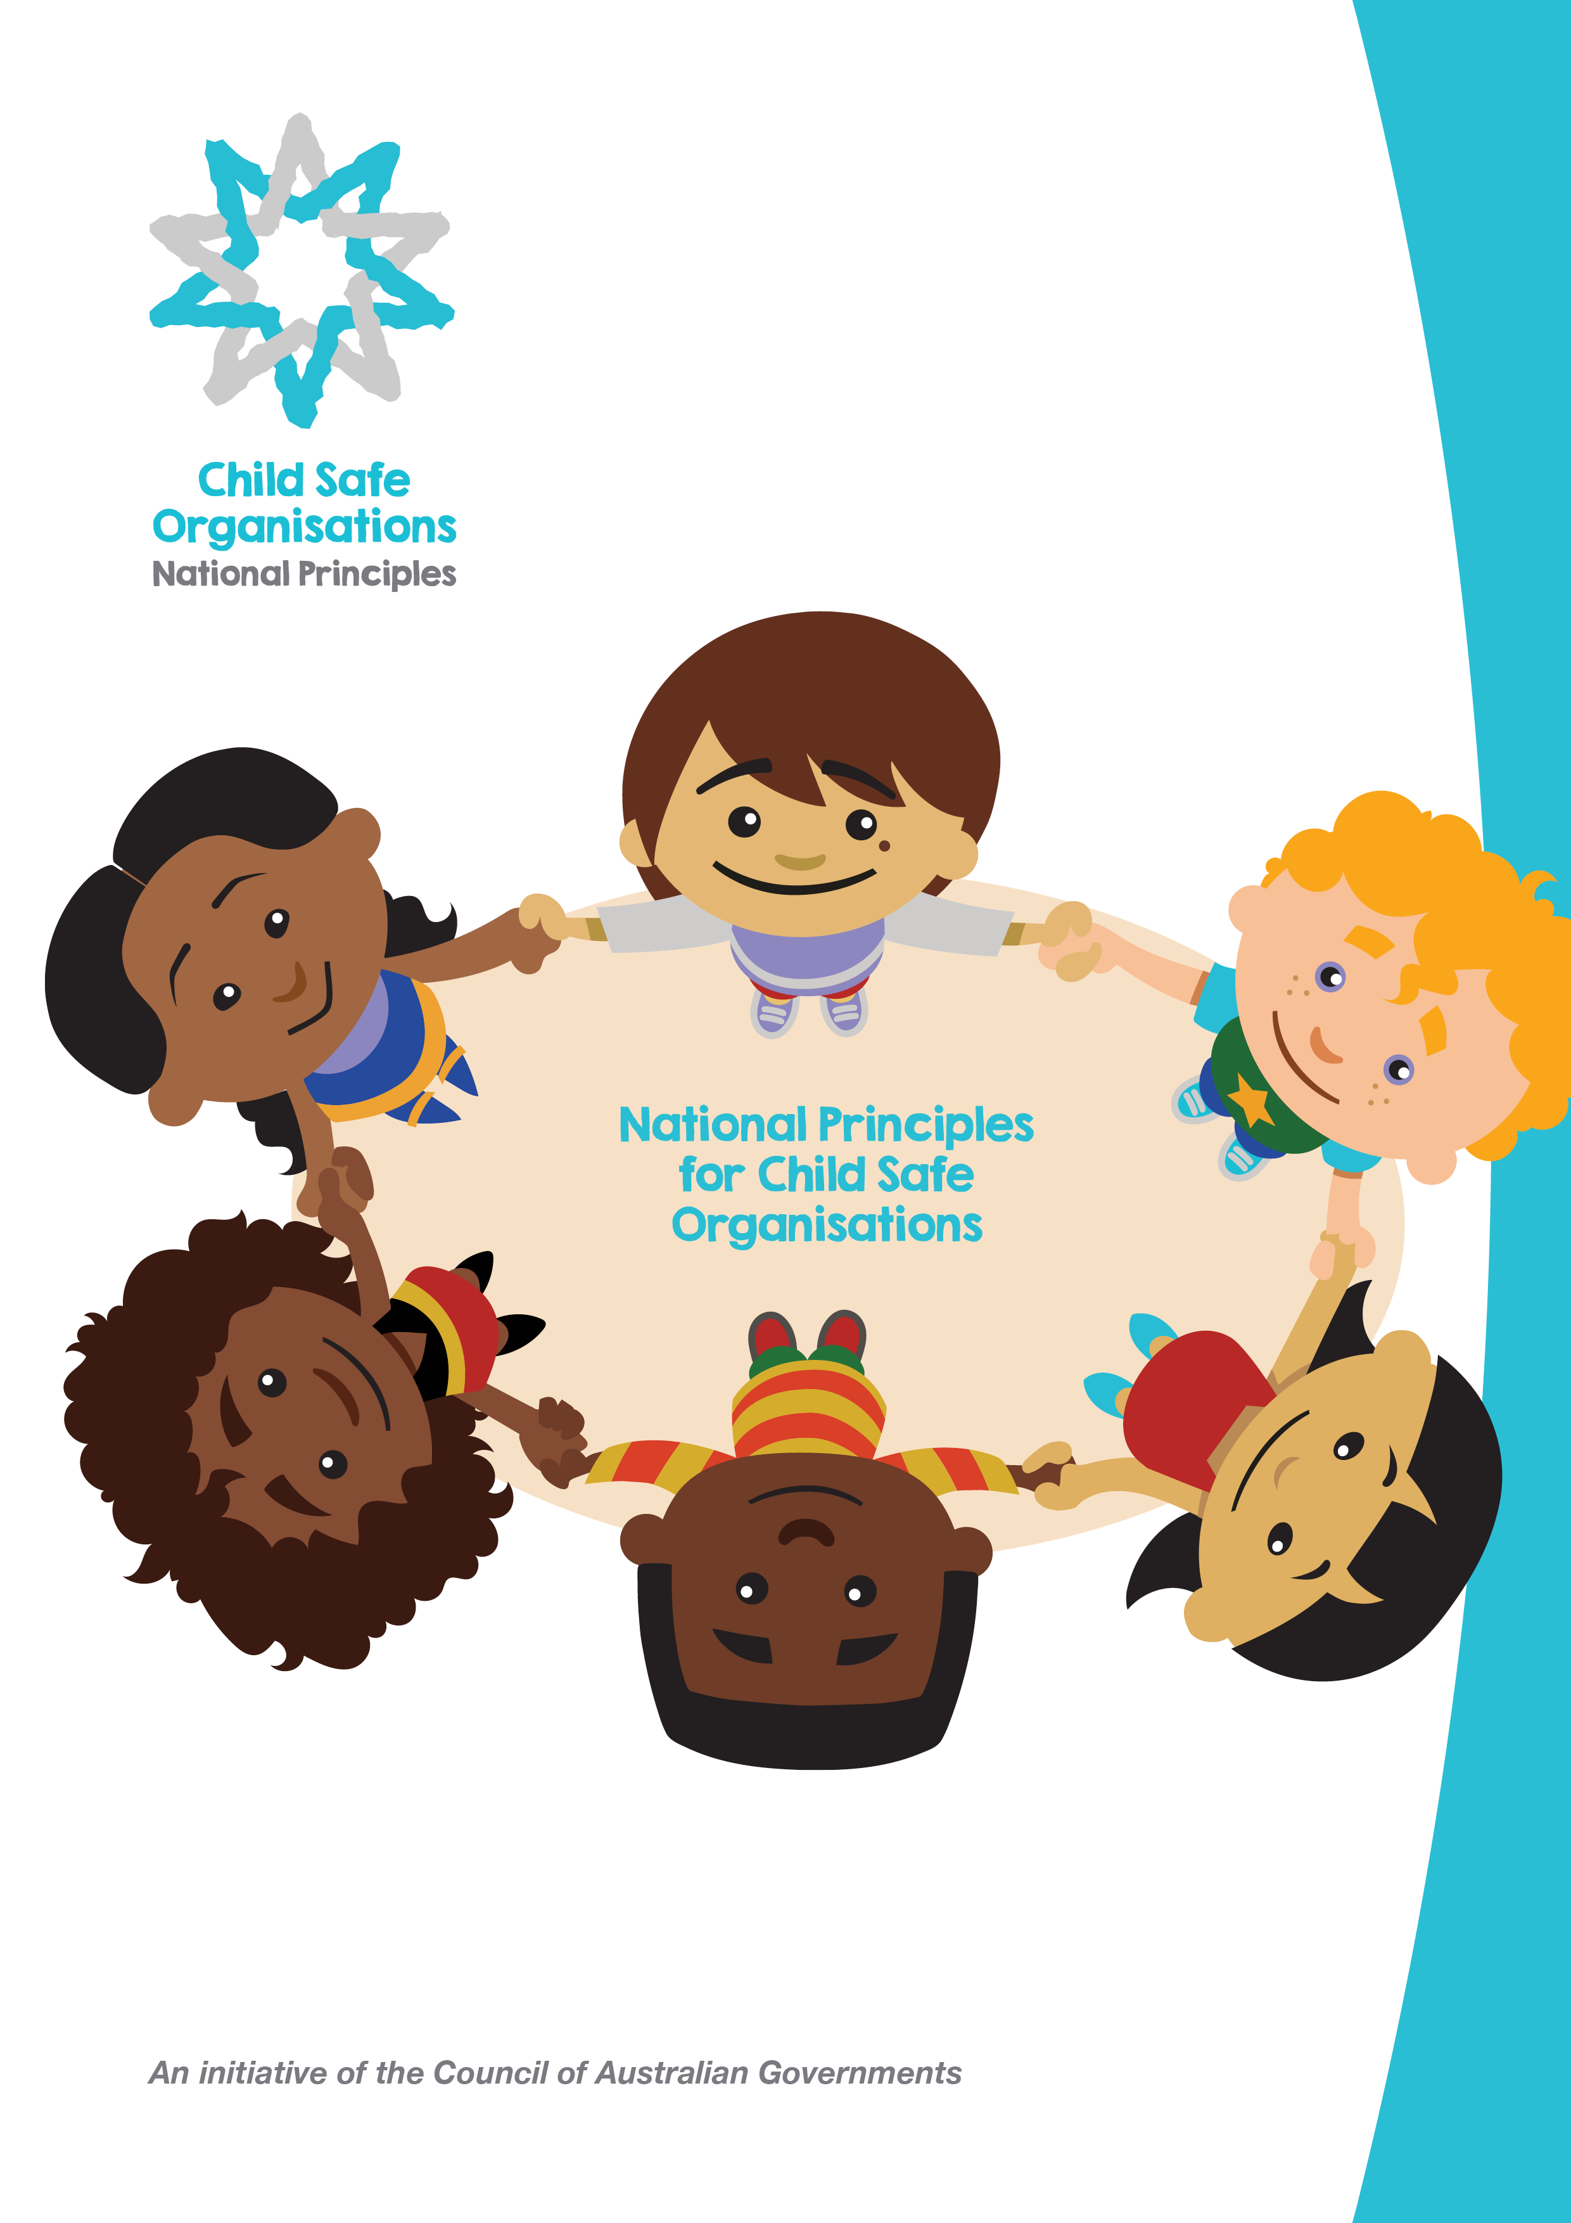

The Australian Human Rights Commission encourages the dissemination and exchange of information presented in this publication and endorses the use of the Australian Governments Open Access and Licensing Framework (AusGOAL).

All material presented in this publication is licensed under the Creative Commons Attribution 4.0 International Licence, with the exception of:
- photographs and images;
- the Commission’s logo, any branding or trademarks;
- content or material provided by third parties; and
- where otherwise indicated.

To view a copy of this licence, visit http://creativecommons.org/licenses/by/4.0/legalcode
In essence, you are free to copy, communicate and adapt the publication, as long as you attribute the Australian Human Rights Commission and abide by the other licence terms.

Please give attribution to:
© Australian Human Rights Commission 2018.

Acknowledgements:
The Australian Human Rights Commission acknowledges the National Principles for Child Safe Organisations project is funded by the Australian Government Department of Social Services and the National Principles have been developed under the oversight and guidance of the Community Services Ministers across all jurisdictions.
Further information:
For further information about the copyright in this publication, please contact:
Communications Unit
Australian Human Rights Commission
GPO Box 5218
SYDNEY NSW 2001
Telephone: (02) 9284 9600
Email: communications@humanrights.gov.au

Foreword

The Royal Commission into Institutional Responses to Child Sexual Abuse (Royal Commission) uncovered shocking abuse of children within institutions in Australia.
The Commission recommended taking action to make organisations across the country safe for children.
The development of the National Principles for Child Safe Organisations (National Principles) is a key national reform in response to these recommendations.
The Principles have been endorsed by all Commonwealth, state and territory governments.
They provide a nationally consistent approach to embedding child safe cultures within organisations that engage with children, and act as a vehicle to give effect to all Royal Commission recommendations related to child safe standards.
I would like to thank all who contributed to the development of the National Principles and their accompanying guidance material.
Development of the National Principles was led by Community Services Ministers across Australia under the Third Action Plan 2015-2018 of the National Framework for Protecting Australia’s Children 2009-2020 and the National Children’s Commissioner, Megan Mitchell, in consultation with a broad range of sectors engaging with children.
Representatives from key advocacy groups and academia also contributed, as well as children and young people themselves.
Adopting the National Principles is an important step to better protecting Australia’s children.

Scott Morrison
Prime Minister of Australia
Chair of the Council of Australian Governments

Preamble

A wide range of organisations work with children and young people throughout Australia. These may be small and community based, such as a sports club or playgroup where families and community members contribute voluntarily, through to more highly organised structures like schools, hospitals and churches. They may also be businesses or organisations employing staff and/or volunteers providing services to and working with children and young people. Some may work across state boundaries.
In 2013, the Australian Government established a Royal Commission into Institutional Responses to Child Sexual Abuse (Royal Commission) in response to community concern about widespread reports of cases where Australian institutions failed to protect children from sexual abuse. The Commission’s final recommendations emphasised that members of the public, children and young people, parents, carers, families and communities should feel confident that organisations working with children provide safe environments in which children’s rights, needs and interests are met.
The National Principles draw on the work of the Royal Commission, Australia’s Children’s Commissioners and Guardians and the 2005 National Framework for Creating Safe Environments for Children.
They provide a national approach to embedding a child safe culture across all sectors of Australian society in which children are involved.
Underpinned by a child-rights approach and based on the standards recommended by the Royal Commission, the National Principles are designed to build capacity and deliver child safety and wellbeing in organisations, families and communities and prevent future harm. In order to allow flexibility in implementation and in recognition of the variety of organisational types, sizes and capacities, the National Principles outline at a high level the 10 elements that are fundamental for making an organisation safe for children.
The National Principles emphasise the importance of culturally safe environments and practices for Aboriginal and Torres Strait Islander children and young people. Aboriginal and Torres Strait Islander families and communities are more likely to access services that are culturally safe and experience better outcomes in such services. This includes improving the way organisations engage with Aboriginal and Torres Strait Islander children and their families, recognising the impact of intergenerational trauma, and respecting cultural diversity.
The National Principles collectively show that a child safe organisation is one that creates a culture, adopts strategies and takes action to promote child wellbeing and prevent harm to children and young people. A child safe organisation consciously and systematically:
- creates an environment where children’s safety and wellbeing is the centre of thought, values and actions
- places emphasis on genuine engagement with, and valuing of children
- creates conditions that reduce the likelihood of harm to children and young people
- creates conditions that increase the likelihood of identifying any harm
- responds to any concerns, disclosures, allegations or suspicions.

The adoption and application of national child safe principles in any institution or organisation across Australia, in which children are involved, is a significant milestone in promoting child safety and wellbeing.

Wheel of Child Safety

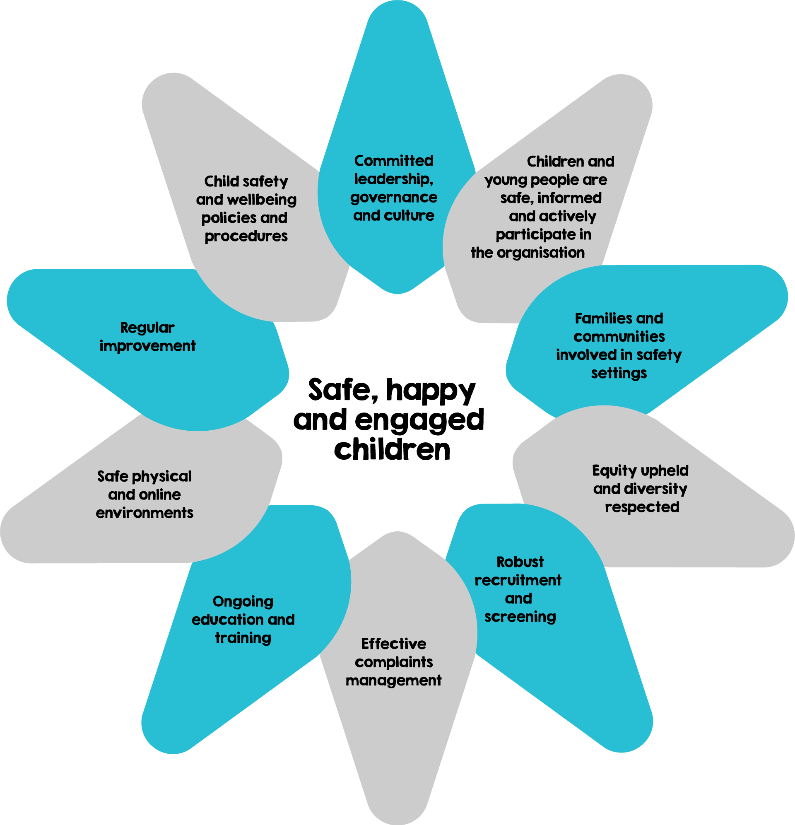

National Principles for Child Safe Organisations

1. Child safety and wellbeing is embedded in organisational leadership, governance and culture.
2. Children and young people are informed about their rights, participate in decisions affecting them and are taken seriously.
3. Families and communities are informed and involved in promoting child safety and wellbeing.
4. Equity is upheld and diverse needs respected in policy and practice.
5. People working with children and young people are suitable and supported to reflect child safety and wellbeing values in practice.
6. Processes to respond to complaints and concerns are child focused.
7. Staff and volunteers are equipped with the knowledge, skills and awareness to keep children and young people safe through ongoing education and training.
8. Physical and online environments promote safety and wellbeing while minimising the opportunity for children and young people to be harmed.
9. Implementation of the national child safe principles is regularly reviewed and improved.
10. Policies and procedures document how the organisation is safe for children and young people.

As of 1 February 2019, all Parties have confirmed their commitment to the National Principles for Child Safe
Organisations as follows:

The Prime Minister of Australia
on behalf of the Commonwealth of Australia

The Hon Scott Morrison MP
The Premier of New South Wales on behalf of the State of  New South Wales  The Hon Gladys Berejiklian MP | The Premier of Victoria on behalf of the State of Victoria  The Hon Daniel Andrews MP
The Premier of Queensland on behalf of the State of Queensland  The Hon Annastacia Palaszczuk MP | The Premier of Western Australia on behalf of the State of Western Australia  The Hon Mark McGowan MLA
The Premier of South Australia on behalf of the State of South Australia  The Hon Steven Marshall MP | The Acting Premier of Tasmania on behalf of the State of Tasmania  The Hon Jeremy Rockliff MP
The Acting Chief Minister of the Australian Capital Territory on behalf of the Australian Capital Territory  Ms Yvette Berry MLA | The Chief Minister of the Northern Territory on behalf of the  Northern Territory  The Hon Michael Gunner MLA

Guidance

Australia ratified the United Nations Convention on the Rights of the Child (CRC) in 1990. Under the Convention, children, like adults, possess human rights. They also have the right to special protection because of their vulnerability to exploitation and abuse. Under the Convention, a child is defined as every human being below eighteen years of age.
The following pages provide detailed guidance on each of the principles to support the adoption of the National Principles across all organisations engaging with children across Australia.
For each principle, the guidance provides:
- the intent and key elements of the principle
- key action areas, showing where organisations should take action to create a culture of child safety
- indicators that the principle is upheld, providing practical examples of signs that the principle is effectively in place
- references to examples of relevant Articles of the CRC.
This guidance is intended to support organisations to consistently and effectively implement the National Principles. It is provided as a best practice guide and allows flexibility in implementation and in recognition of the variety of organisational types, sizes and capacities.
A set of tools and resources to support implementation of the National Principles within institutions can be accessed through the National Office for Child Safety webpage
(https://pmc.gov.au/domestic-policy/national-office-child-safety).

Principle 1
Child safety and wellbeing is embedded in organisational leadership, governance and culture.
Article 3 of the Convention on the Rights of the Child (CRC): All adults should do what is best for children. When adults make decisions, they should think about how their decisions will affect children.
This principle provides guidance on the role of organisational leadership and governance in promoting inclusive and welcoming environments for children and young people, a culture of accountability and the ways in which a child safe culture is developed and maintained.
Adoption of this principle shows that the organisation has a commitment to child safety and wellbeing through all levels of the organisation. Governance arrangements are transparent and include a child safety and wellbeing policy, practice guidance, a Code of Conduct and a risk management framework. Governance arrangements vary depending on the type, nature and size of an organisation. Organisational leadership provides an authorising environment for the sharing of information about risks to children and young people.
Key action areas:
1.1 The organisation makes a public commitment to child safety.
1.2 A child safe culture is championed and modelled at all levels of the organisation from the top down and the bottom up.
1.3 Governance arrangements facilitate implementation of the child safety and wellbeing policy at all levels.
1.4 A Code of Conduct provides guidelines for staff and volunteers on expected behavioural standards and responsibilities.
1.5 Risk management strategies focus on preventing, identifying and mitigating risks to children and young people.
1.6 Staff and volunteers understand their obligations on information sharing and recordkeeping.
Indicators that this principle is upheld:
- The organisation can demonstrate they have publicly available and current documents such as a child safety and wellbeing policy, practice guidance, information sharing protocols, staff and volunteer codes of conduct and risk management strategies.
- The organisational leadership models and regularly reinforces attitudes and behaviours that value children and young people and a commitment to child safety, child wellbeing and cultural safety. This commitment is clear in duty statements, performance agreements and staff and volunteer review processes.
- Staff, volunteers, children and young people have a sound knowledge of children’s rights, including their rights to feel safe and be heard, and the accountabilities that accompany these rights.
- Leaders promote sharing good practice and learnings about child safety and wellbeing

Principle 2
Children and young people are informed about their rights, participate in decisions affecting them and are taken seriously.
Article 12 of the CRC: Children have the right to give their opinion, and for adults to listen and take it seriously.
This principle describes an organisational culture that supports children and young people to understand what child safety and wellbeing means. They are informed about their rights and responsibilities in an age appropriate way. They contribute and actively participate in building an organisational culture that is safe for them.
Children and young people know about the organisation’s commitment to child safety and wellbeing and access relevant information and programs. They recognise safe environments and understand protective strategies. In such environments, children and young people feel comfortable participating in decisions and communicating their views and concerns. Ultimately, however, the responsibility for child safety and wellbeing in an organisation rests with the organisation and its workers.
Staff and volunteers value and respect children and young people’s identity and culture, are comfortable and skilled in engaging with them, understand their developmental needs and build on children and young people’s strengths and capacities.
Key action areas:
2.1 Children and young people are informed about all of their rights, including to safety, information, and participation.
2.2 The importance of friendships is recognised and support from peers is encouraged, to help children and young people feel safe and be less isolated.
2.3 Where relevant to the setting or context, children may be offered access to sexual abuse prevention programs and to relevant related information in an age appropriate way.
2.4 Staff and volunteers are attuned to signs of harm and facilitate child-friendly ways for children to express their views, participate in decision-making and raise their concerns.
Indicators that this principle is upheld:
- The organisation has programs and resources to educate children and young people on their rights including their right to safety and right to be listened to.
- The organisation is proactive in providing age appropriate platforms to regularly seek children and young people’s views and encourage participation in decision-making.
- Staff and volunteers have a good understanding of children and young people’s developmental needs.
- Opportunities for participating are documented and regularly reviewed.
- The organisational environment is friendly and welcoming for children and young people.
- Children and young people participate in decision-making in the organisation, including in relation to safety issues and risk identification.
- Children and young people can identify trusted adults and friends.
- Children and young people are informed about their roles and responsibilities in helping to ensure the safety and wellbeing of their peers.

Principle 3
Families and communities are informed, and involved in promoting child safety and wellbeing.
Article 5 of the CRC: Families have the responsibility to help children learn to exercise their rights, and to ensure that their rights are protected.
This principle outlines the range of ways an organisation can involve families and the community in its approach to child safety and wellbeing, relevant policies and practices and the provision of accessible information. This will help inform parents and carers about safeguarding children and young people and encourage their feedback and input. They will be empowered to speak up and drive conversations regarding child safety and wellbeing and how and when they can raise issues and concerns.
Families have the primary responsibility for the upbringing of their children, and are aware of their children’s primary protective networks. There is wide variety in the structure of families, the role different family members may play in a child’s life, their backgrounds and cultures. Families and carers are best placed to advise about their children’s needs and capabilities and can inform organisations about practices and environments that are safe for them. In a safe environment, children, young people, family and community members feel that their culture and identity are respected.
Key action areas:
3.1 Families participate in decisions affecting their child.
3.2 The organisation engages and openly communicates with families and the community about its child safe approach and relevant information is accessible.
3.3 Families and communities have a say in the development and review of the organisation’s policies and practices.
3.4 Parents, caregivers and the community are informed about the organisation’s operations and governance.

Indicators that this principle is upheld:
- The organisation is responsive to the needs of families and communities, including to cultural safety aspects.
- The organisation creates opportunities for families and communities to be involved in how the organisation operates, including encouraging their children’s participation and feedback.
- The organisation has clear and accessible information for families and communities about the organisation’s operations and policies, including child safety and wellbeing policy, Code of Conduct, record keeping practices and complaints and investigation processes.
- The organisation seeks feedback from families and communities on issues of child safety and wellbeing and incorporates this into their policies and practices.
- The organisation engages with and supports approaches that build cultural safety through partnerships and respectful relationships.

Principle 4
Equity is upheld and diverse needs respected in policy and practice.
Article 2 of the CRC: All children have rights, no matter who they are, where they live, what their parents do, what language they speak, what their religion is, their sex or gender, what their culture is, whether they have disability, whether they are rich or poor.
Equity is upheld and diverse needs respected in policy and practice.
This principle examines how recognition of children and young people’s diverse circumstances enables an organisation to work in a more child centred way and empowers children and young people to participate more effectively. This builds an organisational culture that acknowledges the strengths and individual characteristics of children, and embraces all children regardless of their abilities, sex, gender, or social, economic or cultural background.
A welcoming organisation is one where all children and young people feel comfortable and where services are provided in culturally safe and inclusive ways. This reduces the risk of discrimination, exclusion, bullying and abuse.

Key action areas:
4.1 The organisation, including staff and volunteers, understands children and young people’s diverse circumstances, and provides support and responds to those who are vulnerable.
4.2 Children and young people have access to information, support and complaints processes in ways that are culturally safe, accessible and easy to understand.
4.3 The organisation pays particular attention to the needs of Aboriginal and Torres Strait Islander children, children with disability, children from culturally and linguistically diverse backgrounds, those who are unable to live at home, and lesbian, gay, bisexual, transgender and intersex children and young people.
Indicators that this principle is upheld:
- The organisation has specific policies in place that promote equity and respect diversity for the safety and wellbeing of all children and young people.
- The organisation produces child-friendly material in accessible language and formats that promotes inclusion and informs all children and young people of the support and complaints processes available to them.
- Board members, employees and volunteers champion attitudes and behaviours that respect the human rights of all children and young people, and are inclusive, well informed and responsive to diverse needs.
- Board members, staff and volunteers reflect on how discrimination and exclusion, whether intentional or unintentional, may work against a safe and inclusive culture and they develop proactive strategies to address this.
- Staff and volunteers are trained to recognise and respond effectively to children and young people with diverse needs.

Principle 5
People working with children and young people are suitable and supported to reflect child safety and wellbeing values in practice.
Article 3.3 of the CRC: Children should feel confident about the standards established in an organisation, particularly in the areas of safety, health, number and suitability of staff, as well as supervision.
This principle describes recruitment and staff development policies, including appropriate screening, that are a foundation of child safe organisations. This principle also includes induction training, understanding child safety responsibilities and cultural safety concepts, and appropriate supervision of staff and volunteers. Reporting obligations, training in record keeping and information sharing provide staff and volunteers with relevant practice tools to better safeguard children and young people.
Key action areas:
5.1 Recruitment, including advertising, referee checks and staff and volunteer pre-employment screening, emphasise child safety and wellbeing.
5.2 Relevant staff and volunteers have current working with children checks or equivalent background checks.
5.3 All staff and volunteers receive an appropriate induction and are aware of their responsibilities to children and young people, including record keeping, information sharing and reporting obligations.
5.4 Ongoing supervision and people management is focused on child safety and wellbeing.
Indicators that this principle is upheld:
- The organisation emphasises its commitment to child safety and wellbeing when advertising for, recruiting and screening staff and volunteers.
- Duty statements, selection criteria and referee checks demonstrate children and young people are valued and respected, commitment to child safety and wellbeing, understanding of children’s developmental needs and culturally safe practices.
- Employers, staff and volunteers in an organisation have completed background check requirements.
- Staff and volunteers understand the child safety policy and procedures of the organisation and meet their record keeping, information sharing and reporting responsibilities.
- Ongoing staff support, supervision and performance management processes involve child safety elements.
- The organisation maintains suitable record keeping systems and protocols for staff and volunteers.
- The organisation has a range of tools and processes to monitor and mitigate risk.

Principle 6
Processes to respond to complaints and concerns are child focused.
Article 42 of the CRC: Children have the right to know their rights! Adults should know about these rights and help children learn about them, too.
This principle provides guidance on how human resource management policies and practices and effective complaints management processes should be accessible, responsive to and understood by children and young people, families, staff and volunteers. Complaint management processes will be linked to the Code of Conduct and provide details about where breaches of the Code have occurred. Training will help staff and volunteers to recognise and respond to neglect, grooming and other forms of harm, provide appropriate support to children and young people in these instances and meet legal requirements. This includes training to assist in responding to different types of complaints, privacy considerations, listening skills, disclosures of harm and reporting obligations.
Key action areas:
6.1 The organisation has an accessible, child focused complaint handling policy which clearly outlines the roles and responsibilities of leadership, staff and volunteers, approaches to dealing with different types of complaints, breaches of relevant policies or the Code of Conduct and obligations to act and report.
6.2 Effective complaint handling processes are understood by children and young people, families, staff and volunteers, and are culturally safe.
6.3 Complaints are taken seriously, and responded to promptly and thoroughly.
6.4 The organisation has policies and procedures in place that address reporting of complaints and concerns to relevant authorities, whether or not the law requires reporting, and co-operates with law enforcement.
6.5 Reporting, privacy and employment law obligations are met.
Indicators that this principle is upheld:
- Staff and volunteers are well-informed about their roles and responsibilities, reporting and privacy obligations and processes for responding to disclosures. They feel empowered and supported to draw attention to breaches of the Code of Conduct within the organisation and to challenge these behaviours.
- The complaints handling policy prioritises the safety and wellbeing of children and young people and recognises the role of families and communities in understanding and using the policy.
- Policies and procedures demonstrate regard for fairness to all parties to a complaint or investigation including support and information as appropriate.
- Staff and volunteers have a good knowledge of the different ways children and young people express concerns or distress and disclose harm.
- Information about all complaints and concerns, including breaches of relevant policies or the Code of Conduct, is recorded and analysed, including in relation to processes, timeframes and record keeping practices. Systemic issues are identified and mitigated through this process.
- Children and young people know who to talk to if they are feeling unsafe and know what will happen.
- Timely feedback is provided to children and young people, families, staff and volunteers who raise concerns or complaints. This includes reporting back on incidents, concerns and complaints.

Principle 7
Staff and volunteers are equipped with the knowledge, skills and awareness to keep children and young people safe through ongoing education and training.
Article 19 of the CRC: Children have the right to be protected from being hurt and mistreated, in body or mind.
This principle emphasises the importance of information, ongoing education and training for staff and volunteers. Staff and volunteers build on their knowledge and skills and evidence-based practice tools through professional seminars and memberships, supervised peer discussions, team training days and access to research and publications. This ensures staff and volunteers develop awareness and insights into their attitudes towards children and young people, and have a contemporary understanding of child development, safety and wellbeing. They are able to identify indicators of child harm, respond effectively to children and young people and their families and support their colleagues. Staff and volunteers are able to respond in culturally appropriate ways to children and young people who disclose or show signs that they are experiencing harm inside or outside the organisation.
Staff and volunteers are trained in the rights of children and young people in relation to record keeping, and the possible uses and audiences for records that may be created.
Key action areas:
7.1 Staff and volunteers are trained and supported to effectively implement the organisation’s child safety and wellbeing policy.
7.2 Staff and volunteers receive training and information to recognise indicators of child harm including harm caused by other children and young people.
7.3 Staff and volunteers receive training and information to respond effectively to issues of child safety and wellbeing and support colleagues who disclose harm.
7.4 Staff and volunteers receive training and information on how to build culturally safe environments for children and young people.
Indicators that this principle is upheld:
- The organisation provides regular opportunities to educate and train staff on child safety and wellbeing policies and procedures and evidence-based practice.
- The organisation provides a supportive and safe environment for staff and volunteers who disclose harm or risk to children and young people.
- Staff and volunteers receive training on the rights of children and young people in relation to records being created about children and young people and their use.
- Staff and volunteers recognise the range of indicators of child harm.
- Staff and volunteers respond effectively when issues of child safety and wellbeing or cultural safety arise.

Principle 8
Physical and online environments promote safety and wellbeing while minimising the opportunity for children and young people to be harmed.
Article 17 of the CRC: Children have the right to get information that is important to their wellbeing from radio, newspapers, books, computers and other sources. Adults should make sure that the information children get is not harmful, and help them find and understand the information they need.
This principle highlights that reducing the risk of harm in physical and online environments is an important preventative mechanism. Risk management strategies clarify potential risks where adult to child or child to child interactions occur, or where the physical environment is unsafe.
Technological platforms within organisations provide valuable tools in education, communication and help seeking. Risks associated with these platforms are minimised through all necessary means, including: education of children and young people, parents, staff and volunteers about expectations of online behaviour; the application of safety filters; and communication protocols.
Key action areas:
8.1 Staff and volunteers identify and mitigate risks in the online and physical environments without compromising a child’s right to privacy, access to information, social connections and learning opportunities.
8.2 The online environment is used in accordance with the organisation’s Code of Conduct and child safety and wellbeing policy and practices.
8.3 Risk management plans consider risks posed by organisational settings, activities, and the physical environment.
8.4 Organisations that contract facilities and services from third parties have procurement policies that ensure the safety of children and young people.
Indicators that this principle is upheld:
- The organisation’s risk management strategy addresses physical and online risks, including risks arising from child to child and adult to child interactions and the state and nature of physical spaces.
- The organisation’s policies promote the use of safe online applications for children and young people to learn, communicate and seek help.
- The organisation considers ways in which the physical environment might promote cultural safety.
- Staff and volunteers are proactive in identifying and mitigating physical and online risks.
- Staff and volunteers access and use online environments in line with the organisation’s Code of Conduct and relevant communication protocols.
- Children and young people and their families are informed, in culturally appropriate ways, about the use of the organisation’s technology and safety tools.
- Third party contractors for the provision of facilities and services have appropriate measures in place to ensure the safety and wellbeing of children and young people.

Principle 9
Implementation of the national child safe principles is regularly reviewed and improved.
Article 29 of the CRC: Children’s education should help them use and develop their talents and abilities. It should also help them learn to live peacefully, protect the environment and respect other people.
This principle emphasises that child safe organisations seek to continuously improve their delivery of child safe services and their operations. They also conduct reviews to ensure that organisational policies and procedures, including record keeping practices, are being implemented by staff and volunteers. The participation and involvement of staff, volunteers, children and young people, families and community mentors in these reviews will strengthen the organisation’s child safeguarding capacities. This includes the importance of reporting on the finding of reviews, and sharing good practice and learnings on a regular basis. Regular reviews ensure that organisations address new challenges or concerns that arise.
Key action areas:
9.1 The organisation regularly reviews, evaluates and improves child safe practices.
9.2 Complaints, concerns and safety incidents are analysed to identify causes and systemic failures so as to inform continuous improvement.
9.3 The organisation reports on the findings of relevant reviews to staff and volunteers, community and families and children and young people.
Indicators that this principle is upheld:
- The organisation seeks the participation of children and young people, parents and communities in its regular reviews of child safety and wellbeing policies, procedures and practices.
- Child safety and wellbeing indicators are included in documentation used for reviews.
- Review outcomes are considered and implemented to improve child safe practices.
- Regular analysis of complaints demonstrates improvement in child safe practices.

Principle 10
Policies and procedures document how the organisation is safe for children and young people.
Article 4 of the CRC: Organisations have a responsibility to ensure children’s rights are protected. They can help families to protect children’s rights and create an environment where children can grow and reach their potential.
This principle outlines the importance of organisations having a clearly documented child safety and wellbeing policy. This will ensure that all stakeholders, including organisational staff and volunteers, children and young people and their families and carers, are aware of how the organisation is planning to meet its obligations to create an environment that is safe for children. Partner agencies or organisations funded to provide services to children and young people should demonstrate adherence to child safety and wellbeing policies and practices.
Documenting policies and procedures ensures consistent application of child safe practices across the organisation. It also enables organisations to examine, through review processes, adherence to child safety and wellbeing principles and practices.
Key action areas:
10.1 Policies and procedures address all national child safe principles.
10.2 Policies and procedures are documented and easy to understand.
10.3 Best practice models and stakeholder consultation informs the development of policies and procedures.
10.4 Leaders champion and model compliance with policies and procedures.
10.5 Staff and volunteers understand and implement policies and procedures.
Indicators that this principle is upheld:
- The organisation’s child safety and wellbeing policy is comprehensive and addresses all ten of these Principles.
- The organisation’s child safety and wellbeing policy and procedures are documented in a language and format that is easily understood and accessible to staff, volunteers, families and children and young people.
- Audits of the organisation’s policies and procedures provide evidence of how the organisation is child safe through its governance, leadership and culture.
- Practice within the organisation is consistent across the board and compliant with child safe policies and procedures, including culturally safe work practices.
- Interviews or surveys of children and young people, families and community members demonstrate confidence in and awareness of the organisation’s policies and procedures on promoting a child safe culture.
- Surveys of executive, staff and volunteers demonstrate high levels of understanding of policies, procedures and practice requirements of the organisation.

The Australian Human Rights Commission was engaged by the Australian Government Department of Social Services to lead consultations and development of the National Principles for Child Safe Organisations. The goal is to build cultures in all organisational settings to advance the safety and wellbeing of children and young people.

Work continues with national sector organisations on the implementation of the National Principles and development of related resources.
For more information on Child Safe Organisations please go to:
https://childsafe.humanrights.gov.au/
Contact: childsafe@humanrights.gov.au

For more information on the National Office for Child Safety go to:
https://pmc.gov.au/domestic-policy/national-office-child-safety
Contact: nationalofficeforchildsafety@pmc.gov.au

