Child Safe Organisations:

Charter of commitment to
children and young people

A Charter of Commitment to Children and Young People is a set of commitments or promises that an organisation makes to create a safer environment for its children and young people.
This example Charter of Commitment is based on the National Principles for Child Safe Organisations (National Principles) and showcases commitments an organisation could make to foster child safety. These commitments are based on what children and young people have told the National Children’s Commissioner during consultations on the National Principles about what they consider are the important characteristics of safety in an organisation.
Organisations may display the completed Charter in a public facing area in their organisation so that children and young people, parents and carers and the broader community can see it and know that leaders, staff and volunteers in the organisation are committed to ensuring the safety and wellbeing of children and young people.
About the National Children’s Commissioner’s consultations
The National Children’s Commissioner consulted with the children and young people in a range of organisations using a child-friendly version of the National Principles to establish which principles were the most important to them, what the concept of safety meant to them and how their rights could be upheld in a child safe organisation. We asked the children and young people to indicate the promises they would like their organisation to make to them so that they are safe. The Charter illustrates the recurring themes from the consultations. While these themes capture all ten principles, children and young people in your organisation may want to highlight some in particular.
Tools to help organisations develop their own Charter
To assist with the implementation of the National Principles, organisations are encouraged to develop their own Charter of Commitment as this encourages engagement between the leadership team, staff, volunteers and children and young people involved with your organisation. It empowers everybody in your organisation to be child safe within a child rights based framework.
You can use this Charter as a guide to help group themes that emerge from your consultations. The commitments your organisation makes will vary depending on what the children and young people tell you. For example, a young person may tell you, “I want to be included in decisions that are made”. What would this look like as a commitment from your organisation? Your promise could sit within the theme “Voice” as “We (the organisation) promise that you (children and young people) are included in decisions that affect you; this means we will have weekly meetings where you can have your say.”
This resource is accompanied by a poster template, or accessible word version, that organisations can edit and customise to make as their own.

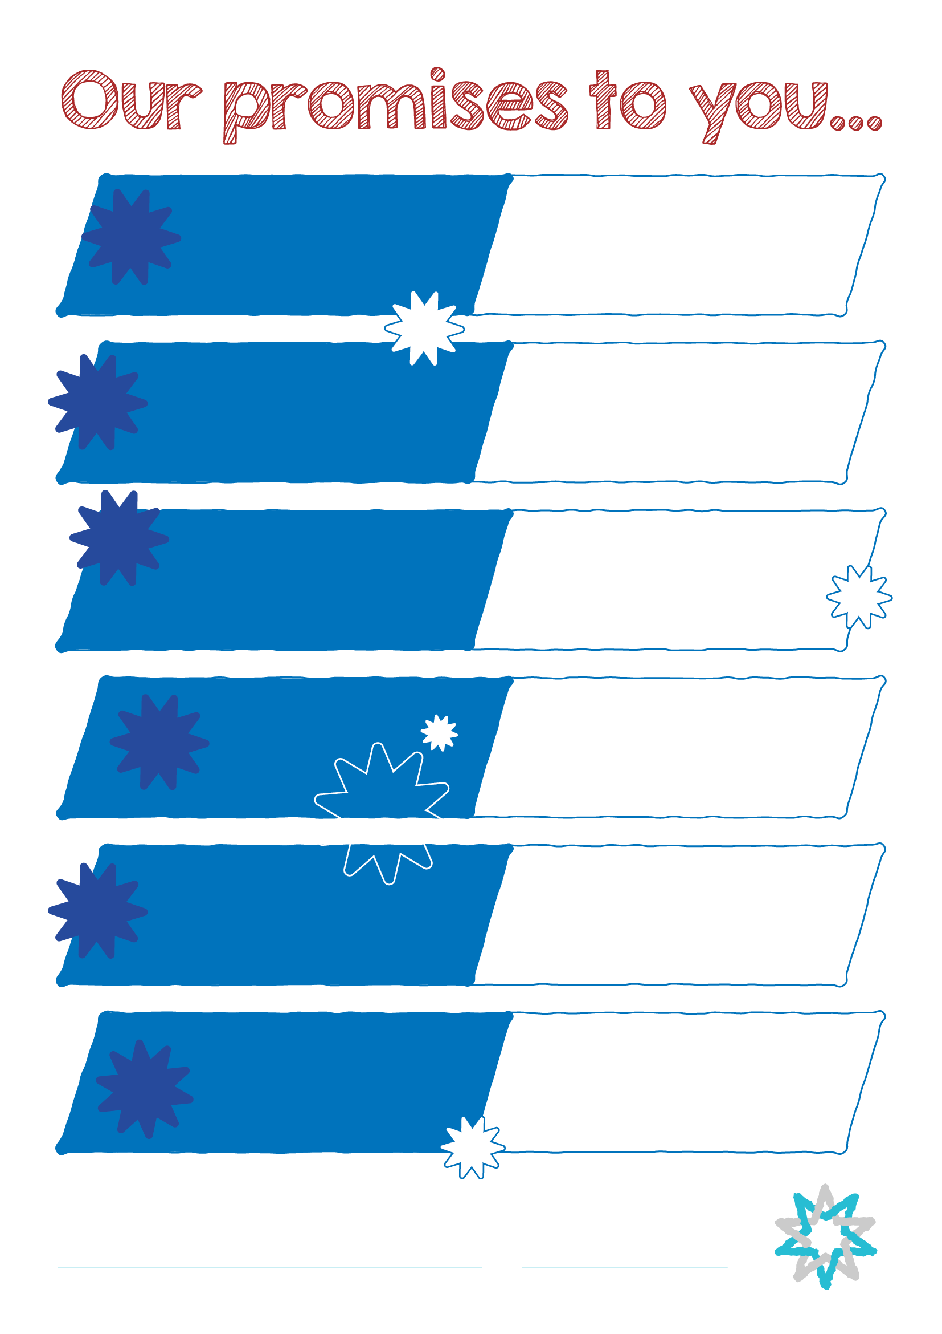
Date
Name of organisation
We will make our place happy and comfortable for you.
You can trust that we will care about your needs and feelings and will support you. We will continue to get better at what we do.
Safety
Trust
Respect
Inform
Help
We will listen and act on what you tell us. We will help you with your hopes and dreams as well as your worries and fears.
a voice
Give you
We will make sure there are lots of ways for you to have a say and be involved.
We will give you information about your physical, emotional and online safety, and what to do if you feel unsafe.
We will treat everyone equally no matter where they are from or who they are. We will make sure everyone feels included and welcome.
Date
Name of organisation
This means…

This means…

This means…

This means…

This means…

This means…

Safety
Trust
Help
a voice
Give you
Inform
Respect

