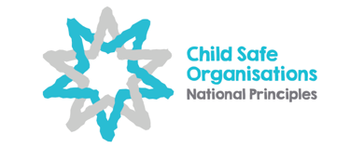

Child Safe Organisations:

Guide for parents
and carers

As a parent or carer you will experience a range of organisations where your child will be cared for, play, learn, develop new skills and meet other children and adults. This Guide will help you think about how each organisation operates and its safety and wellbeing arrangements for children.

Children have a right to safety, emotionally and physically. Everyone has a role to play in keeping children safe from harm. Harm can take many forms such as accidental injury, exposure to physical hazards, bullying, neglect, emotional abuse, physical abuse and sexual abuse. Organisations providing services to or working with children, whether run by staff or volunteers, have a duty of care to keep children safe and to respect their rights.
This Guide suggests some areas to think about, look for and ask about as you make an assessment about whether an organisation is suitable for your child. The Guide is based on elements of a child safe organisation, as identified in the National Principles for Child Safe Organisations. In particular, Principle 3 emphasises the importance of families and communities being informed and involved in promoting child safety and wellbeing.

Before you visit or join
It’s a good idea to do some research on the organisation before you visit or join.

- Contact them
- Visit their website
- Speak to other parents and carers

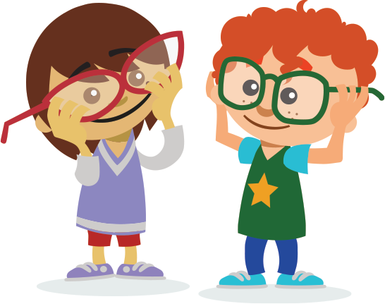
Things to consider:
- Who runs the organisation and who is responsible for child safety and wellbeing? E.g. A director, management committee or volunteers.
- What are the ages of children involved in the organisation and how may this impact your child?
- Do you know other parents or carers who have been involved with the organisation and what their views are?
- How will the organisation meet your child’s individual needs and circumstances? E.g. Disability or cultural needs.
- Is there a child safety and wellbeing policy, code of conduct, or rules of behaviour for staff, volunteers and children?
- Do the staff and volunteers have working with children or background checks?

When you visit
If you can, visit at different times, so you get a good sense of how the organisation operates.

Things to look for:
- Is there information on display about child safety and wellbeing, or a public commitment to child safety?
- Does the physical environment seem safe? E.g. Can children be seen at all times? Is the place clean, well-maintained and well lit?
- How do the staff and volunteers engage with the children? E.g. Are they approachable and actively involved with the children?
Things to ask about:
- Is there adequate supervision of children? E.g. Staff/volunteer to child ratio.
- Do staff and volunteers receive regular training on areas such as first aid, child protection, and mandatory reporting?
- Are children taught about personal safety, their rights and where they can go for help?
- How does the organisation respond to children’s behavioural challenges? E.g. Is there a documented behavioural management approach?
- Is there a policy that children are only to be collected by authorised persons?
- Is there a policy for late drop-offs and late pick-ups? E.g. Checking about a child’s whereabouts with a parent or carer; processes for informing the organisation about changes to usual drop-off or pick-up times.
- How are onsite visitors and contractors supervised to ensure child safety?
- How, and to whom, can children, parents and carers raise concerns or make complaints?
- Are children given opportunities to participate in decisions and matters that affect them?
- What is the policy about taking and sharing photographs or recordings of children?
- How is online communication with children, E.g. Social media or emails, managed to ensure safety?
- Are there policies to assess risks and safeguard children when they go offsite? E.g. On excursions or camps.
- How does the organisation show it is welcoming and inclusive to all families and children with different cultural backgrounds and circumstances?

After you visit
Children see and experience things very differently to adults.

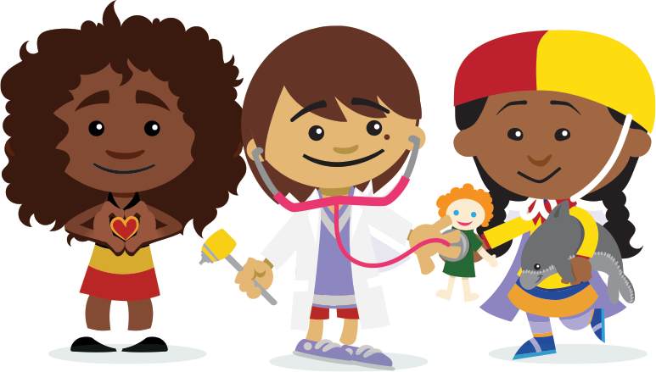
These are some questions to prompt discussion with your child.
- Did you and your child feel welcome during your visit?
- What did you and your child like about the organisation?
- What did you and your child not like or not feel comfortable with during your visit?
- What other questions or concerns do you have about this organisation?

Your relationship with an organisation may be short or long-term. To ensure the organisation continues to provide a safe environment for your child, it is important to keep in touch with the organisation and stay informed. You can do this by:
- maintaining regular and direct contact with staff
- subscribing to newsletters
- following information on social media
- attending meetings, being involved in committees or groups
- volunteering, or
- participating in reviews of child safety and wellbeing policies.
As well as speaking with your child and family, it is important that you raise any concerns. This may include speaking with staff or management, relevant oversight or registration bodies or support services.
Key messages for
parents and carers
- Help children to speak up about their rights, including their right to be safe
- Teach children what to do when they feel unsafe
- Ask children what they think and how they feel
- Choose organisations carefully
- Get involved with your child’s organisation and keep asking questions
- Get to know the staff and volunteers
- Give feedback to the organisation about child safety and wellbeing issues
- Act on your concerns – speak up within or outside the organisation

More information
This Guide is not a comprehensive list of all considerations. The following links provide further information and resources:
Child Safe Organisations: for information, practical tools and resources on the National Principles for Child Safe Organisations, visit https://childsafe.humanrights.gov.au. For information on support services, visit https://childsafe.humanrights.gov.au/support/support-services.
National Office for Child Safety: https://pmc.gov.au/child-safety.
State and territory child safe initiatives and resources: https://childsafe.humanrights.gov.au/tools-resources/links-resources.
Office of the eSafety Commissioner: for information, practical tools and resources on online safety, visit the Office of the eSafety Commissioner website at https://www.esafety.gov.au/.
Australian Institute of Family Studies: for information and resources on child abuse and neglect prevention, visit https://aifs.gov.au/cfca/topics/web-resources-child-abuse-and-neglect-prevention.
For helplines and telephone counselling services for children, young people and parents, visit https://aifs.gov.au/cfca/publications/helplines-and-telephone-counselling-services-children-young-people-and-pare.
Raising Children Network: for parent helplines, visit https://raisingchildren.net.au/grown-ups/services-support/about-services-support/helplines and for information on child health and wellbeing services, visit https://raisingchildren.net.au/grown-ups/services-support/services-families/child-health-services.

